Diffraction Spectra of
Green Jadeite
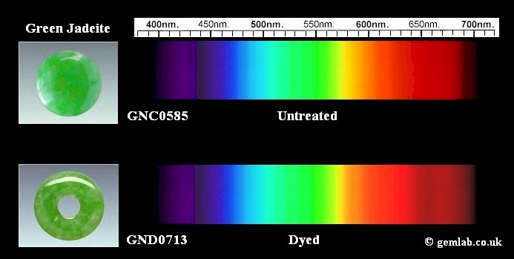
S

Colour | Pale to bright emerald green
Cause of colour | Chromium
Optical Character | Biaxial positive ( Polycrystalline)
Pleochroism | Not detectable
Colour change | No
Spectrum; no polar, calibration in nm. | Untreated – A strong line in violet at 437 with a weaker line at 433 due to iron. Also a line in deep red at 691 due to chromium and weaker lines at 630 and 655 may also be seen. Treated (Dyed) – Diffuse broad band centred at approximately 650 and in some specimens a weak diffuse 437.
Ordinary ray | Not applicable
Extraordinary ray | Not applicable
Alpha ray | Not detectable
Beta ray | Not detectable
Gamma ray | Not detectable
Emission lines | No
Database reference | None yet
Notes | The diagnostic line at 437 due to iron may occur also in colourless jadeite

