[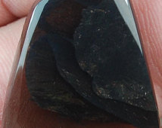](https://www.etsy.com/au/listing/184688713/superb-fire-obsidian-cabochon?ref=market) [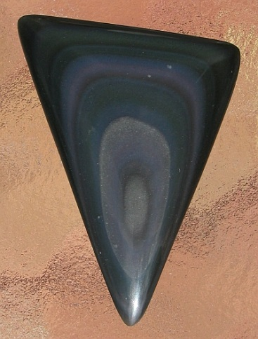](http://www.google.com.au/url?sa=i&rct=j&q=&esrc=s&source=images&cd=&cad=rja&uact=8&ved=0CAcQjRxqFQoTCKvC7dbsgccCFWQcpgod_CkEKw&url=http://www.donniesrockytreasures.com/store/c2/Miscellaneous_Cabochons.html&ei=ZpG5Vav3AuS4mAX805DYAg&psig=AFQjCNFuUC1wfL1NYoXX3EJfXFFqaP03PA&ust=1438310961468870)

Peacock Obsidium

[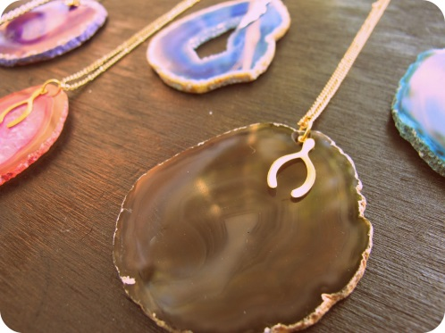](http://www.google.com.au/url?sa=i&rct=j&q=&esrc=s&source=images&cd=&cad=rja&uact=8&ved=0CAcQjRxqFQoTCPbdw8LtgccCFeHZpgodKPUHhA&url=http://dearseptemberstore.blogspot.com/2011_01_01_archive.html&ei=R5K5VbaeNOGzmwWo6p-gCA&bvm=bv.99028883,d.dGY&psig=AFQjCNGoHVAnMzrg-Qn-b0YR85dOrJG8bg&ust=1438311318272795)[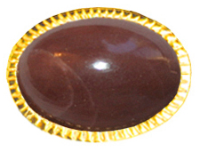](http://www.google.com.au/url?sa=i&rct=j&q=&esrc=s&source=images&cd=&cad=rja&uact=8&ved=0CAcQjRxqFQoTCLjwzvLtgccCFSQ4pgodB24BpQ&url=http://coutureaccessories.com/semi-precious-stones-6.html&ei=rJK5VbjqKqTwmAWH3IWoCg&bvm=bv.99028883,d.dGY&psig=AFQjCNGoHVAnMzrg-Qn-b0YR85dOrJG8bg&ust=1438311318272795)[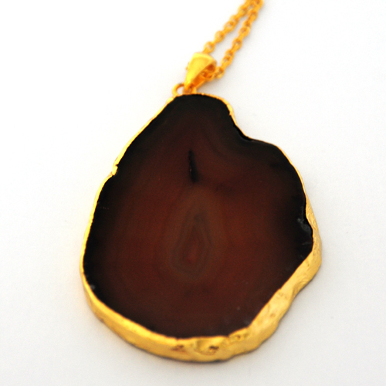](http://www.google.com.au/url?sa=i&rct=j&q=&esrc=s&source=images&cd=&cad=rja&uact=8&ved=0CAcQjRxqFQoTCMSVhf7tgccCFQckpgodnBoCWg&url=http://www.samesamejewellery.co.uk/same-same-collection/chocolate-crystal-agate-pendant/prod_581.html&ei=xJK5VcSjKIfImAWctYjQBQ&bvm=bv.99028883,d.dGY&psig=AFQjCNGoHVAnMzrg-Qn-b0YR85dOrJG8bg&ust=1438311318272795)

AGATE