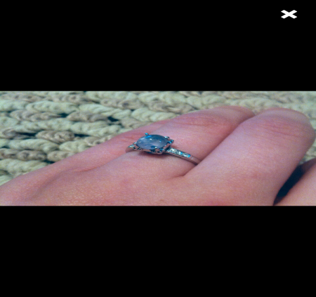[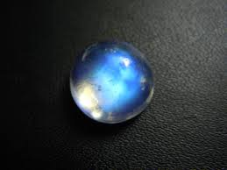](https://www.google.com.au/imgres?imgurl=https://img0.etsystatic.com/000/0/6232492/il_fullxfull.308849774.jpg&imgrefurl=https://www.etsy.com/listing/92111796/blue-rainbow-moonstone-cabochon-gorgeous&docid=iaoiOs5DG41_XM&tbnid=NNT-6_H__z3F_M:&w=1500&h=1125&ved=0CAIQxiBqFQoTCIbnx4HsncgCFQWVlAodO00OUQ&iact=c&ictx=1)[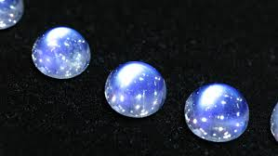](https://www.google.com.au/imgres?imgurl=http://www.gia.edu/cs/Satellite?blobcol%3Dgfile%26blobheader%3Dimage%2Fjpeg%26blobkey%3Did%26blobtable%3DGIA_MediaFile%26blobwhere%3D1355958196722%26ssbinary%3Dtrue&imgrefurl=http://www.gia.edu/moonstone-quality-factor&docid=lwEaVHeFYqOZcM&tbnid=eziwGaUwN-JY8M:&w=636&h=358&ved=0CAIQxiBqFQoTCOqvu5XsncgCFYyglAodtvEIyA&iact=c&ictx=1)[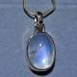](https://www.google.com.au/imgres?imgurl=http://www.crystalarium.com/media/catalog/product/cache/1/thumbnail/9df78eab33525d08d6e5fb8d27136e95/m/o/moonstone-pend-cco-067.jpg&imgrefurl=http://www.crystalarium.com/index.php/blue-moonstone-17-99ct-cabochon-handcrafted-14k-gemstone-pendant.html&docid=uxbTiPun5gR0PM&tbnid=cwua1e5C0FbWyM:&w=576&h=578&ved=0CAMQxiAwAWoVChMIgNurnOydyAIVA7CUCh1QkQ08&iact=c&ictx=1)

[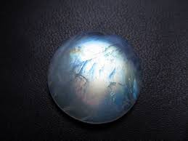](https://www.google.com.au/imgres?imgurl=https://static2.artfire.com/uploads/product/8/468/79468/6079468/6079468/large/aaa_rainbow_moonstone_cabochon_20_mm_21_95_cts__4076a32a.jpg&imgrefurl=https://www.artfire.com/ext/shop/product_view/gemsnjewelry/6079468/aaa_rainbow_moonstone_cabochon_20_mm_21_95_cts_/indie_supplies/handmade_supplies&docid=V4BP827zgn71_M&tbnid=QGhviSYrd19_lM:&w=500&h=375&ved=0CAIQxiBqFQoTCOXI27DsncgCFUWelAodtpEFkw&iact=c&ictx=1)[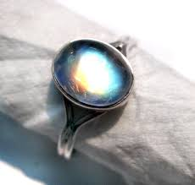](https://www.google.com.au/imgres?imgurl=https://img1.etsystatic.com/000/1/6539605/il_fullxfull.322954777.jpg&imgrefurl=https://www.etsy.com/market/moonstone_cabochon&docid=9cIYWCsdARPGlM&tbnid=D0NnPgnzGsd6SM:&w=1113&h=1063&ved=0CAIQxiBqFQoTCO2Jn73sncgCFcyglAodFhkASQ&iact=c&ictx=1)

[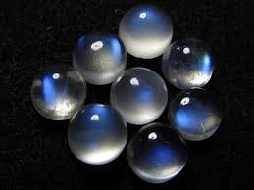](https://www.google.com.au/imgres?imgurl=https://static1.artfire.com/uploads/product/7/537/47537/5947537/5947537/large/aaaa_srilanka_moonstone_cabochon_blue_moon_round_shape_5_mm_-_8_pcs_f65a63e5.jpg&imgrefurl=https://www.artfire.com/ext/shop/product_view/gemsnjewelry/5947537/aaaa_srilanka_moonstone_cabochon_blue_moon_round_shape_5_mm_-_8_pcs/indie_supplies/handmade_supplies&docid=S10AKf4-NhWCXM&tbnid=MADDqBvis71a9M:&w=500&h=375&ved=0CAIQxiBqFQoTCNTGzcfsncgCFYqklAodiZ4DKw&iact=c&ictx=1)